Mahmoud Khalifa

23-March-2021

System Architecture and Requirments

V1.0

Contents

1. System Architecture 2

2. Websites Structure 2

3. Software Prerequisites 2

# System Architecture

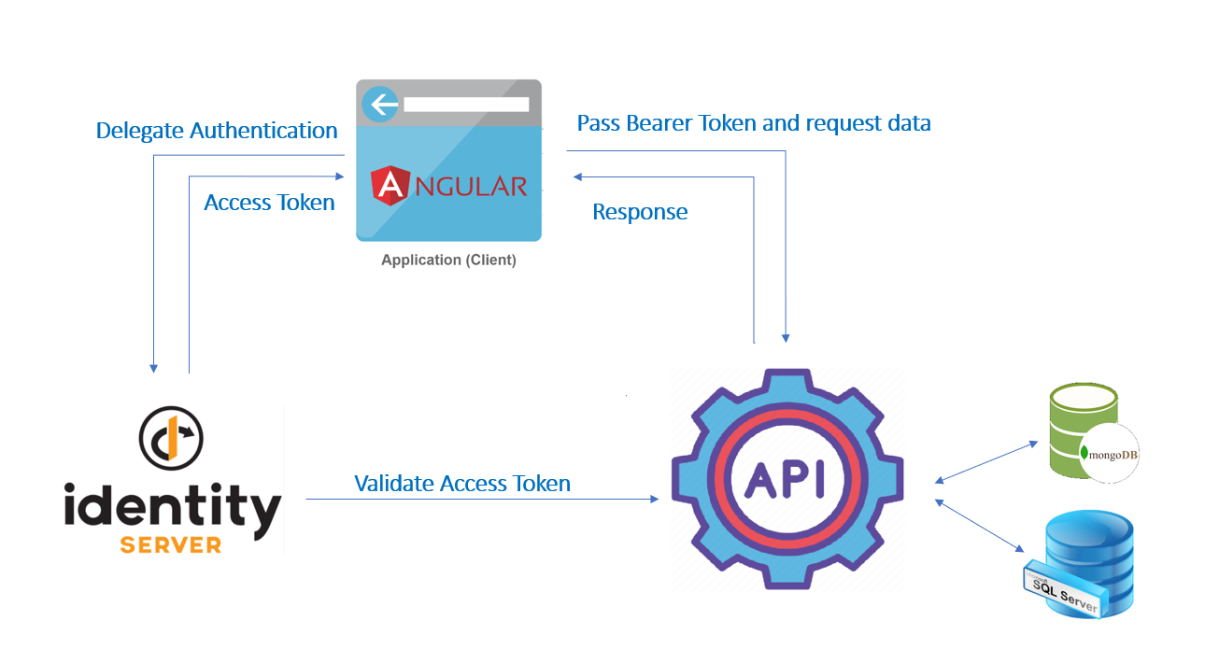

# Websites Structure

We have 4 website running

1. Identity Server: Website for authenticating and authorizing the user. User need to use it to login and get his access tokens
2. Frontend Website, responsible for user interaction. User navigate through this website after login, depending on his access tokens and roles
3. API website, this is used for processing and storing data. It has all business logic. All end points are protected with the authorized access tokens provided by user login
4. Files website for loading generated certificates

# Software Prerequisites

The follow software needs to be installed

* IIS. Full installation needed
* .Net Core 3.1
* SQL 2017 or higher
* MongoDB
* IIS-ReWrite Module
* Access to Email Server